Ayush Goyal
190905522 CSE D Roll 62

Computer Networks Lab 3: Wireshark & GNS3

Part 1: Study of Application Layer Protocols using Wireshark

Q 3.1. Retrieve web pages using HTTP. Use Wireshark to capture packets for analysis. Learn about most common HTTP messages. Also capture response messages and analyze them. During the lab session, also examine and analyze some HTTP headers.

Http request and response packets are as shown below:
First 2 GET and responses give us the home page and the favicon and then the next 2 sets of GET and response are the 2 pages acessed in the website: http://info.cern.ch/

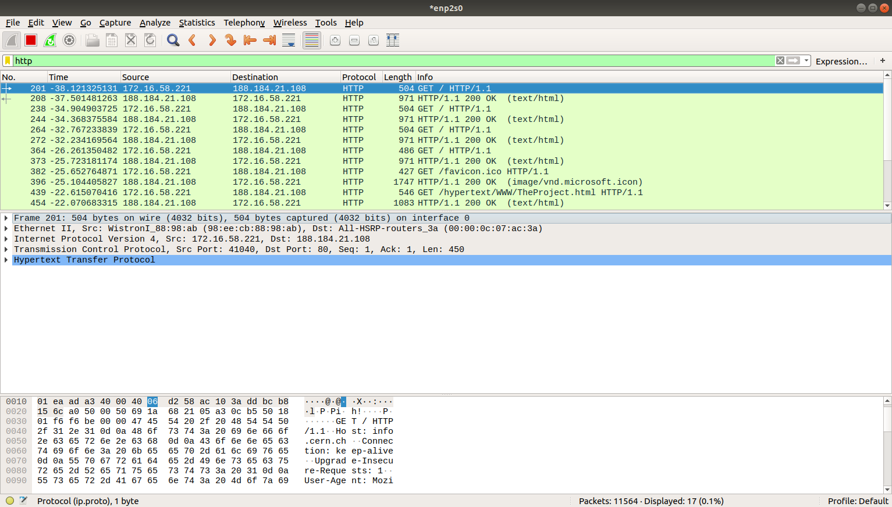

For the “Project” page the http headers are as shown below:
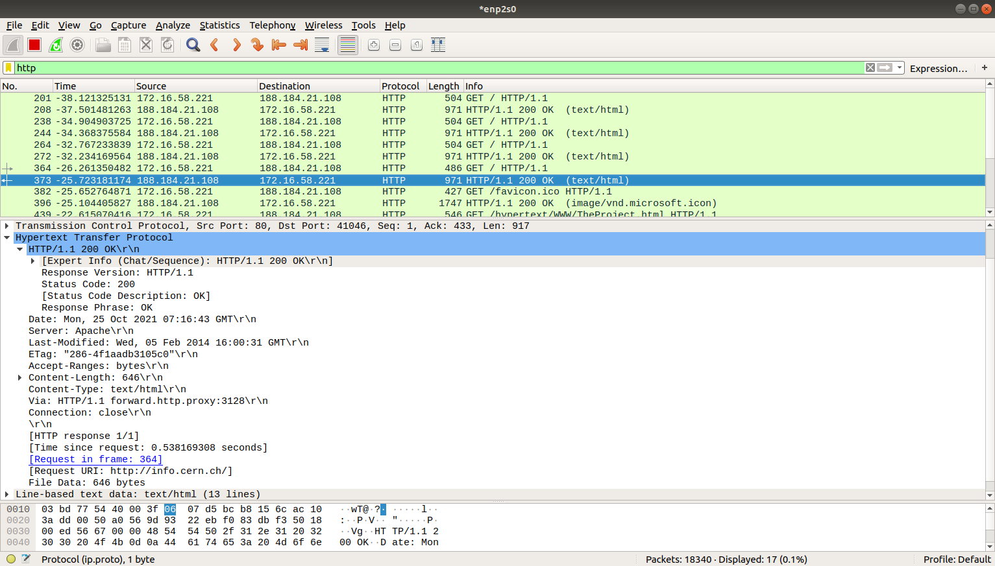
Http response for the “Project” i.e., the HTML document snippet is shown as below in the screenshot:

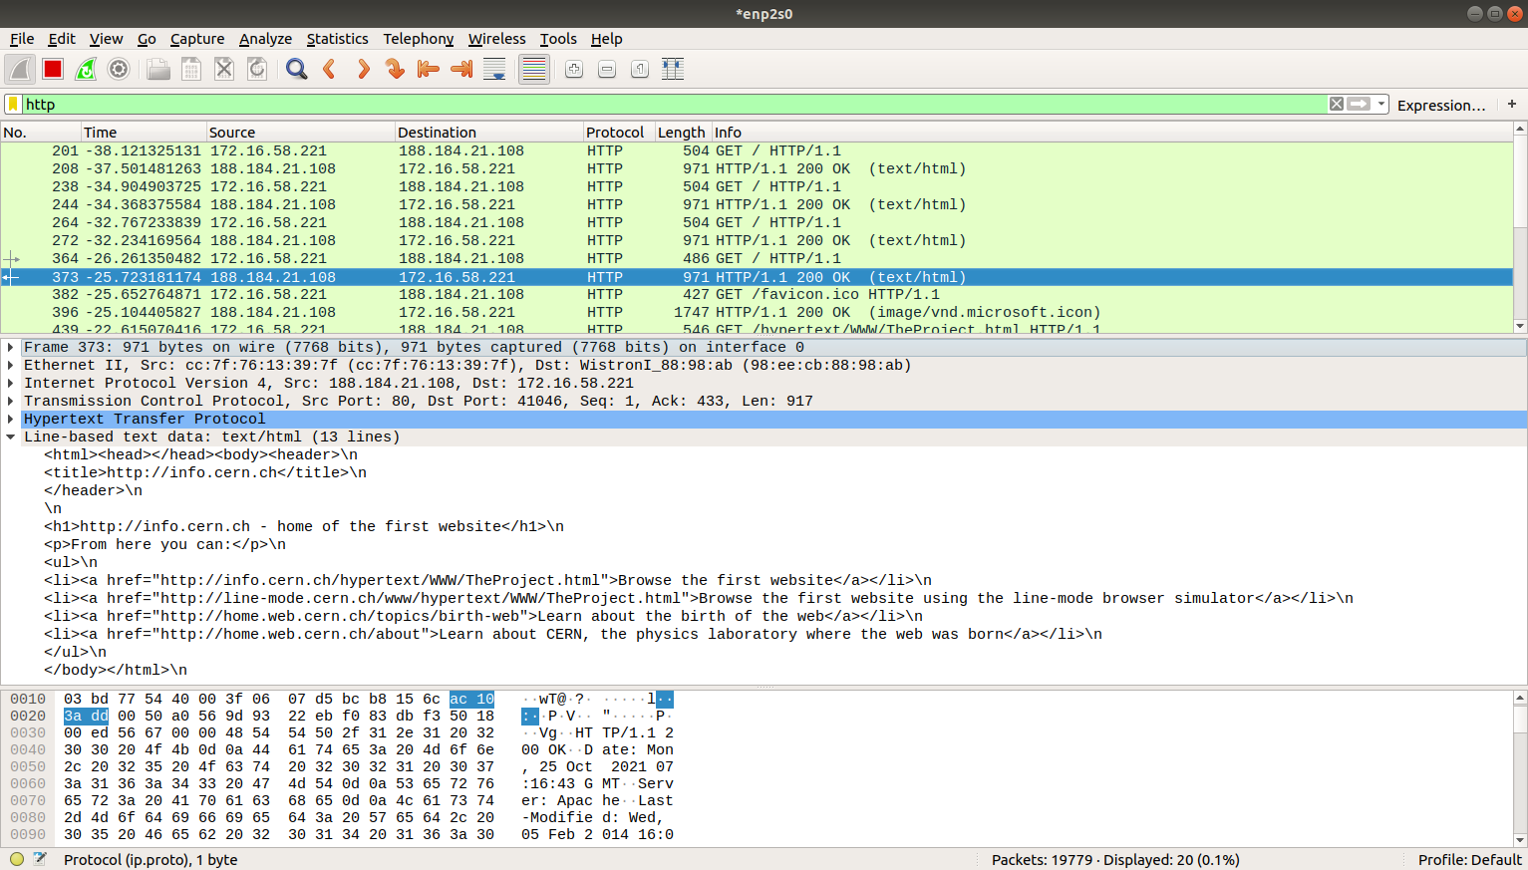

Q 3.2. Use FTP to transfer some files, Use Wireshark to capture some packets. Show that FTP uses two separate connections: a control connection and a data-transfer connection. The data connection is opened and closed for each file transfer activity. Also show that FTP is an insecure file transfer protocol because the transaction is done in plaintext.

We access FTP via terminal and execute commands as shown below:
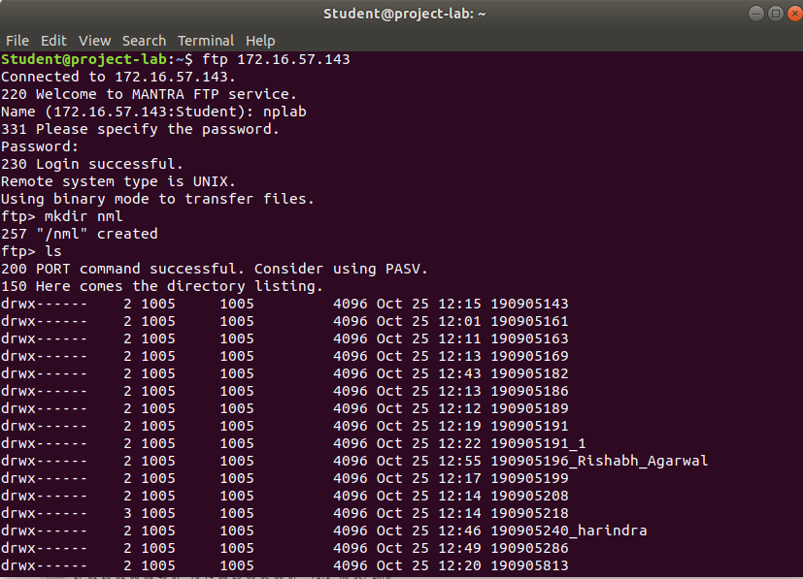

In FTP protocol we see the initial welcome message as ResponseWe see the username and password being askedNote that the password manipal@123is sent as plaintext and hence FTP is not a secure transfer protocol.A SYST request is sent when ls command is executed.

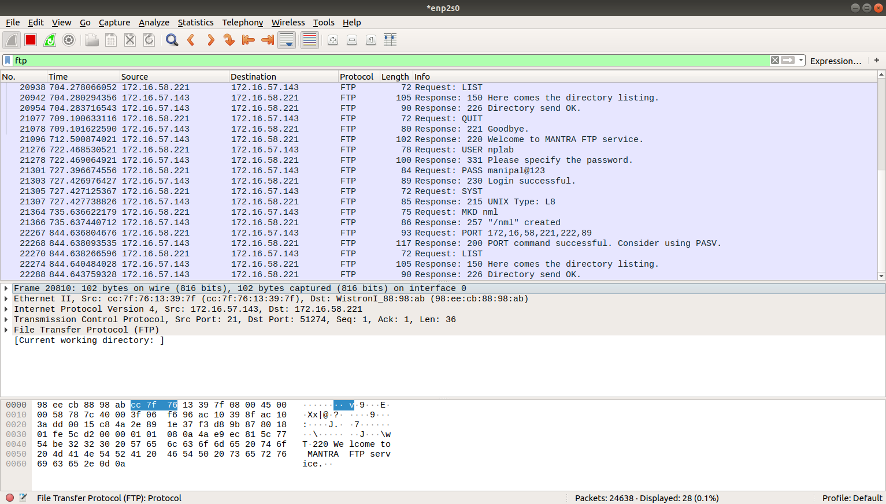

Q 3.3. Analyze the behavior of the DNS protocol. In addition to Wireshark [Several network utilities are available for finding some information stored in the DNS servers. Eg.dig utilities (which has replaced nslookup). Set Wireshark to capture the packets sent by this utility.]

Analyzing the DNS protocol when a request for www.wikipedia.orgis made. As seen in the image below, DNS uses the UDP protocol in the transport layer. The source port for the UDP protocol is 53 and the destination port is 51601. The request is sent from source address 172.16.19.203 to destination address 172.16.58.221.

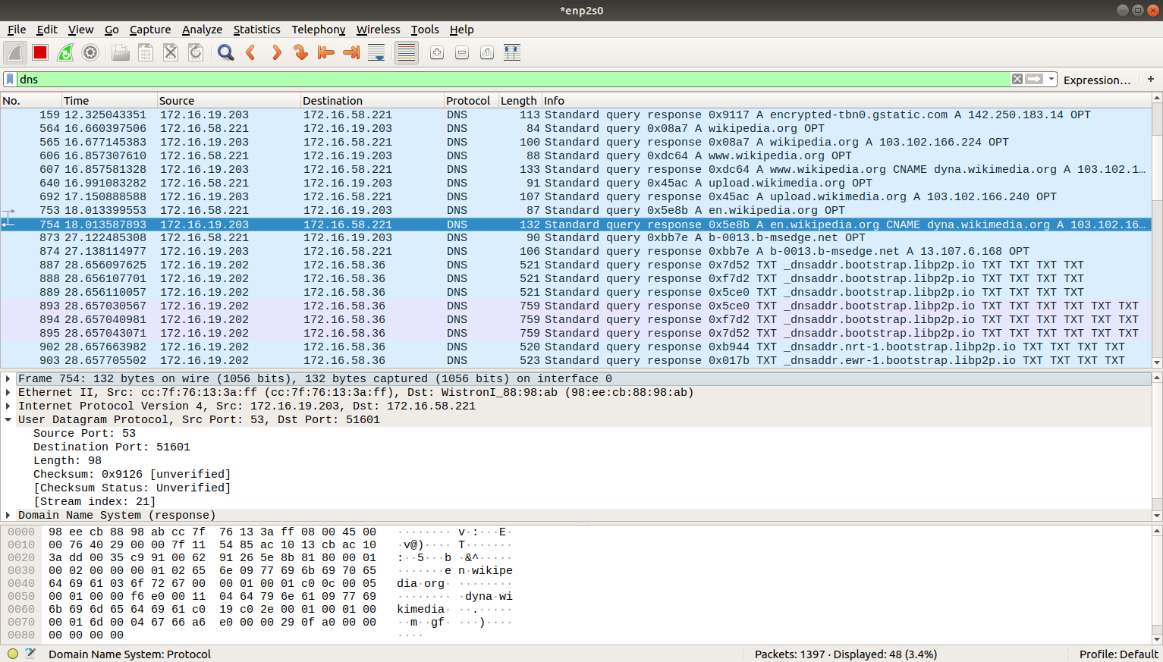
We see the DNS request being made to resolve the Url to actual address. Note that we use UDP and not TCP for DNS. We note that in the response the A entry i.e., the address is shown.

Part 2: Study of Network Devices in GNS3

Q 4.1 (a,b,c,d,e) and Q 4.3
Design network configuration shown in Figure 4.1 for all parts. Connect all four VMs to a single Ethernet segment via a single hub as shown in Figure 4.1. Configure the IP addresses for the PCs as shown in Table 4.1.
a. On PC1, view the ARP cache with showarp
b. Start Wireshark on PC1-Hub1 link with a capture filter set to the IP address ofPC2.
c. Issue a ping command from PC1toPC2:
PC1% ping 10.0.1.13 –c3
Observe the ARP packets in the Wireshark window. Explore the MAC addresses in the Ethernet headers of the captured packets.
Direct our attention to the following fields:
• The destination MAC address of the ARP Request packets.
• The Type Field in the Ethernet headers of ARP packets.
d. View the ARP cache again with the command arp -a. Note that ARP cache
entries can get refreshed/deleted fairly quickly (~2minutes).
show arp
e. Save the results of Wireshark.

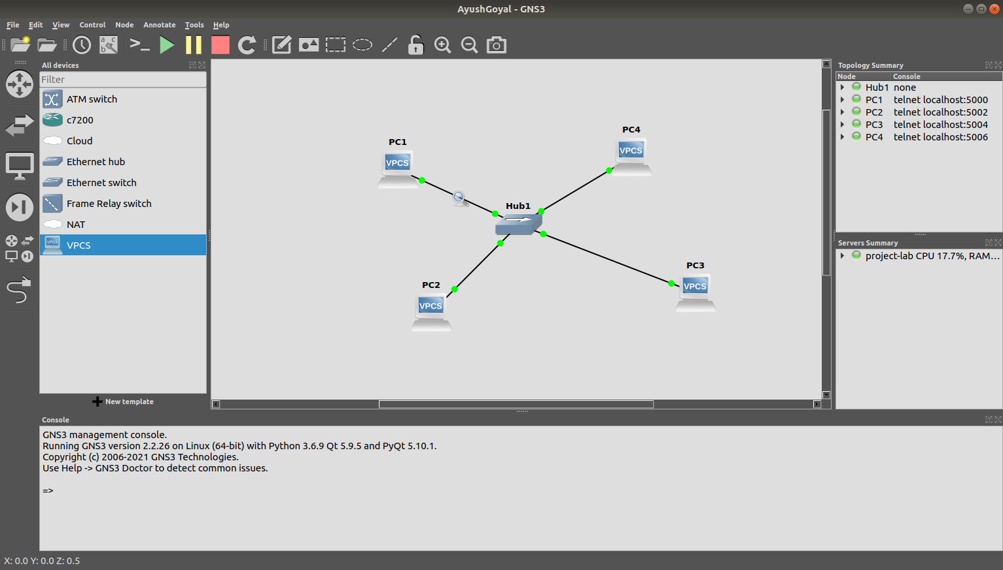

We make a ping to PC2 from PC1 while capturing packets from PC2 to Hub.We notice the request and reply pairs. We also notice the initial broadcast asking where the destination PC is and the corresponding response.

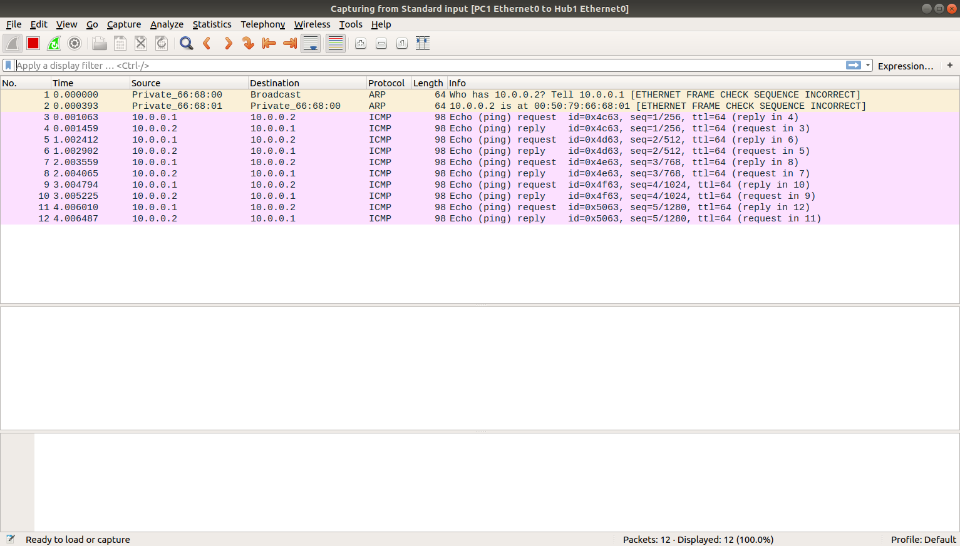
Now when we ping from PC1 to PC4, we see a similar broadcast asking for the location, but we notice that even the request and reply are tracked even though PC2 is not involved. This is characteristic of the Hub as it works on the principle of broadcasting packets and not routing them exactly like a switch.

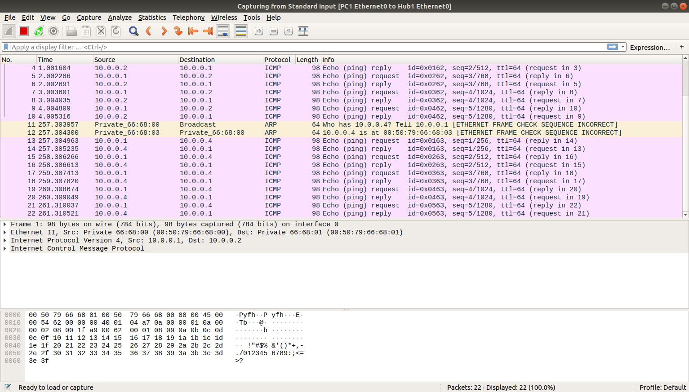

2. We notice the cache entry when we run show arp on PC1

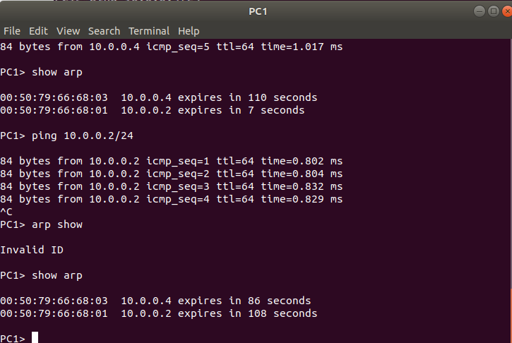
We notice that when we send the same ping request before the arp table entry expires, the initial broadcast asking for the location is not sent, as the location is already known from the cache.
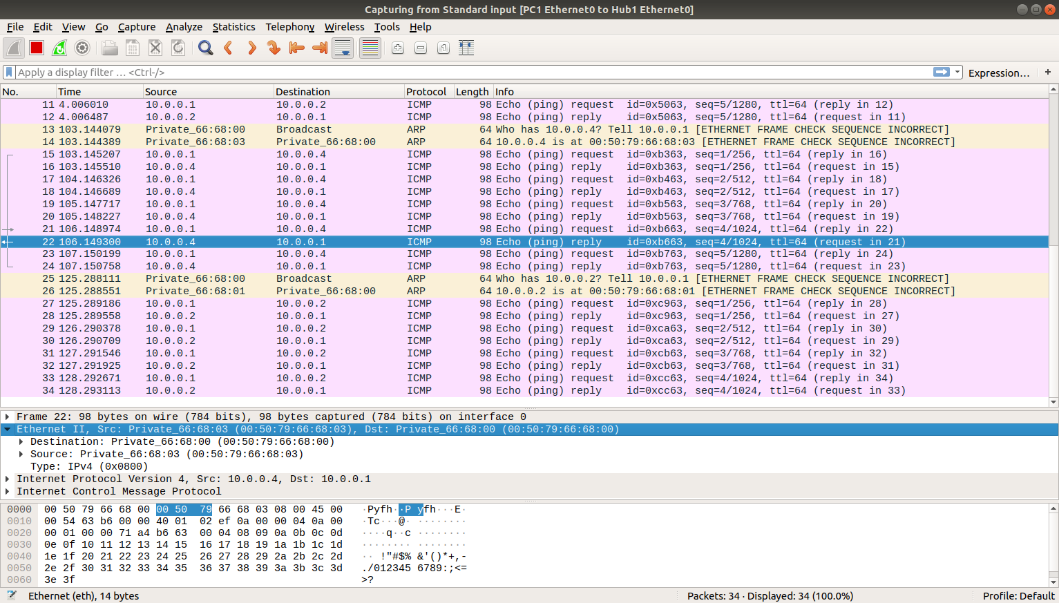

Destination MAC address of the ARP Request packets: 00:50:79:66:68:00
Type field in the ethernet headers is Ipv4 (0x0800)

3. When using a Switch and tracking PC2 to Switch, and ping from PC1 to PC2 we observer no change as compared to Hub.

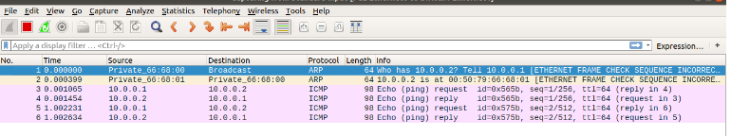
But, when we ping PC4 from PC1We notice that the initial broadcast asking for the location of PC4 is the same but the subsequent request and responses are not seen as Switch routes the packets only to the involved Pcs and does not broadcast like Hub.

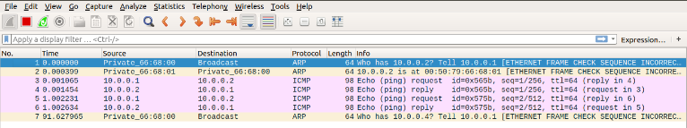

THE END

